5.17: a)
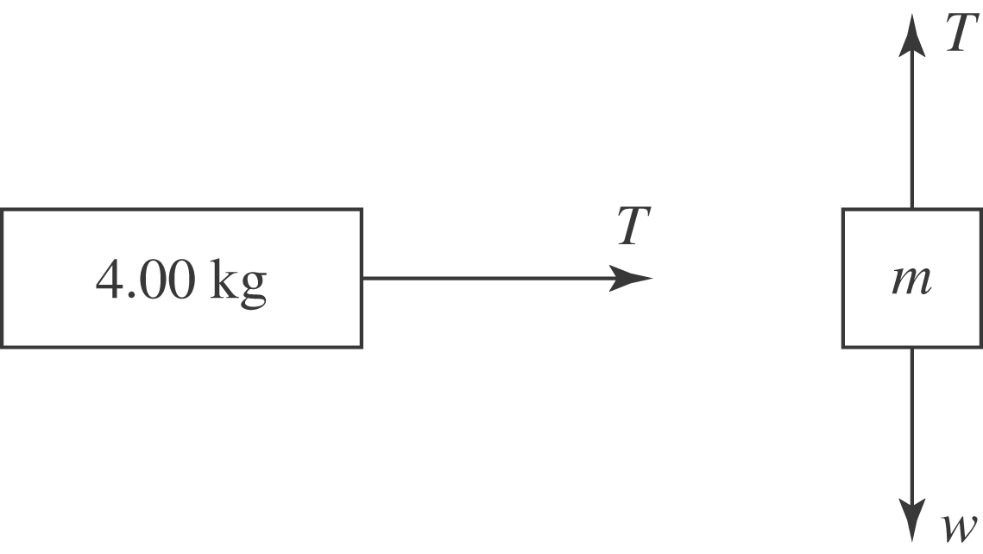

b) In the absence of friction, the net force on the 4.00-kg block is the tension, and so the acceleration will be 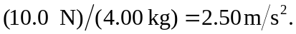 c) The net upward force on the suspended block is 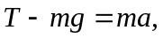 or 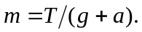 The block is accelerating downward, so 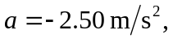 and so d) 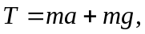 so 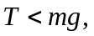 because 